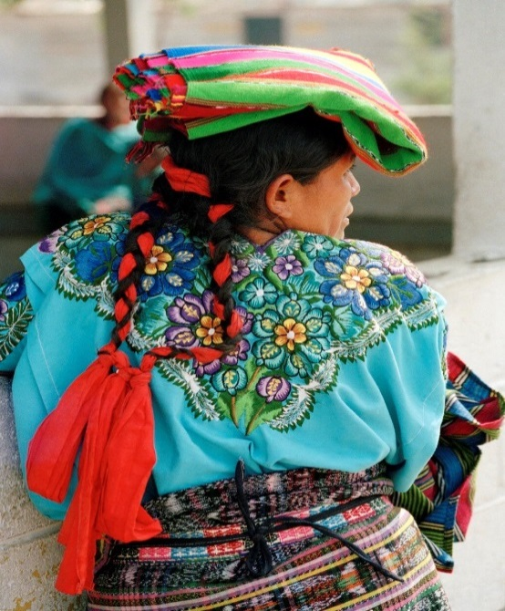
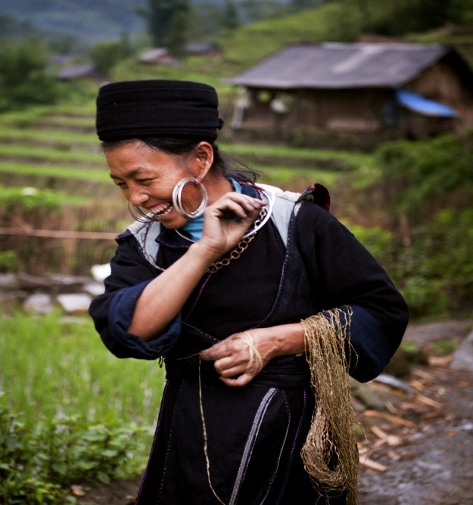
INVITATION

UN Women and the International Indigenous Women’s Forum invite you to a
High Level Side Event:
Affirming the Beijing and Lima Plans of Action for Indigenous Women and Girls
To be held during the World Conference on Indigenous Peoples, a High Level Plenary Meeting of the UN General Assembly
23rd September 2014
12.30-14.00
19th Floor Conference Room, Daily News Building, 220 E. 42nd Street

Speakers
Dr. Phumzile Mlambo-Ngcuka: Executive Director, UN Women
Ms. Aili Keskitalo: President, Sami Parliament of Norway
Ms. Otilia Lux de Coti: Executive Director, International Indigenous Women’s Forum
Ms. Victoria Tauli-Corpuz: United Nations Special Rapporteur on the Rights of Indigenous Peoples
Ms. Soyata Maiga: Special Rapporteur on Women’s Rights and Chairperson of the Working Group on Indigenous Populations/Communities of the African Commission on Human and Peoples’ Rights
Mr. Raja Devasish Roy: Traditional Chief and Member of the United Nations Permanent Forum on Indigenous Issues
Ms. Rosalina Tuyuc Velásquez: Mayan human rights activist, Guatemala

MCs: Andrea Landry & Aili Liimakka Laue, Indigenous Youth Caucus

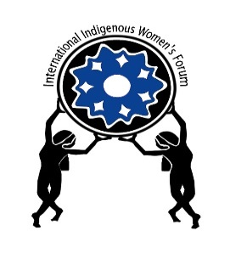
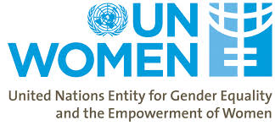
Background note

On 26 June 2014, UN Women launched a global campaign in the lead up to the 20th anniversary of the Fourth World Conference on Women. Unanimously adopted by 189 countries, the Beijing Declaration and Platform for Action (BDPfA) is a visionary blueprint for gender equality and the empowerment of women. The campaign is geared towards galvanizing public debate, engaging younger generations, and renewing political will and commitment to accelerate the implementation of the Platform.

In October 2013, the International Indigenous Women’s Forum (FIMI) and other interest groups successfully held the World Conference of Indigenous Women in Lima, Peru, an event which reviewed progress and challenges in the implementation of the commitments of the Second Decade of the World's Indigenous Peoples, the Cairo Plan of Action, the Beijing Platform for Action, and the Post-2015 development agenda from the perspective of indigenous women. Its outcome, the Lima Position Document and Plan of Action calls for concerted efforts at addressing persisting violence, poverty, racism and discrimination faced by indigenous in various fronts, such as in their ability to participate in decision making, access basic services and productive resources.

UN Women and FIMI are therefore using the countdown to the Beijing +20 review and the forthcoming World Conference on Indigenous Peoples (WCIP) to celebrate the achievements of indigenous women and girls and to reaffirm their aspirations.

The two organizations believe that a high level side event will catalyze attention and action on the two Plans of Action for the effective realization of the rights of indigenous women, particularly within the context of the post-2015 architecture.

The event brings together stakeholders from across society—Member States, indigenous Civil Society Organizations and UN Agencies.

For further information and RSVP please contact:
Megan Kammerer
Legal Intern
Leadership & Governance Section
megan.kammerer@unwomen.org
Ext 4845

